**Software Requirements and Design Document**

**For**

**Group 4**

Version 4.0

**Authors**:

Brenden G

Stephen J

Benjamin W

Logan L

# Overview

“Beneath the Manor” is a rouge-like dungeon crawl game with 2d graphics and randomly generated levels. The player will navigate through rooms attempting to reach the deepest point in the maze while avoiding enemies and collecting items. The player’s top-down view will encompass one room at a time, including doors or openings that lead to other rooms. The layout of each floor (what rooms border each other, and the location of rooms with stairs leading to other floors) will be randomly generated.

In addition to the game itself, the game will be downloadable from a website that also includes tutorial and background flavor information about the game. The website will have a home, faq, download, and guide page. All of which will have content that will relate to the game.

# Functional Requirements

For game:

* When user presses left arrow, the character moves to the left. (High Priority)
* When user presses right arrow, the character moves to the right. (High Priority)
* When user presses up arrow, the character moves to the up. (High Priority)
* When user presses down arrow, the character moves to the down. (High Priority)
* When the user goes through a door, a new room will be generated. (High Priority)
* When the user steps on coins, the gold will be incremented. (High Priority)
* When the user goes up stairs, a new floor will be randomly generated. (High Priority)
* When the user steps on an item, he picks up the item. (Medium Priority)
* A dialog box will pop up with story when you press the button to start the game and you must hit continue to get to the game. (Low Priority)

For website:

* When the button is clicked the game downloads for both Windows and Mac. (High Priority)
* When the NavBar is used the other pages load and connect properly to each other. (Medium Priority)
* Connect the homepage using a nav bar to the other pages such as guide, download, and faq. (Medium Priority)
* Provide parallax properties to website containers. This means that there is dynamic movement on the page while scrolling. (Low Priority)
* Provide a guide to the game and answers to questions about the game in the form of an FAQ and Guide page. (Low Priority)

# Non-functional Requirements

For game:

* Quality will be high when user is moving the character from space to space which will be measured by the runtime it takes to press the key and move the character.
* Maintainability of bounds so the user does not crash the game. This will be measured by the areas the user is allowed to interact with.
* Scalability of the screen so the game always looks as intended (game has no random lines or weird sizing). This will be measured by any noticeable gaps between the game spaces.
* Usability of .jar file. This will be measured by the time it takes to download and load the jar file.

For Website:

* Scalability, for the website. The hosting platform Amazon Web Services (AWS) is a pay for what you use model. This will be measured by the amount of visits to the website.
* Safety, for the website. In the near future once the website is complete we are going to add the free SSL certificate provided to make the website secure. This will encrypt data and provide users with a safer experience. This will be measured by the amount of access normal visitors will have with the website.
* Availability, aiming for the game to work on both Windows and Mac. This will be measured by the usability of the jar file on both platforms.
* Accessibility, the game is accessible from the website through the download button. This will be measured by the ability to download the game and the amount of time it takes.

# Use Case Diagram

Website Use Case Diagram

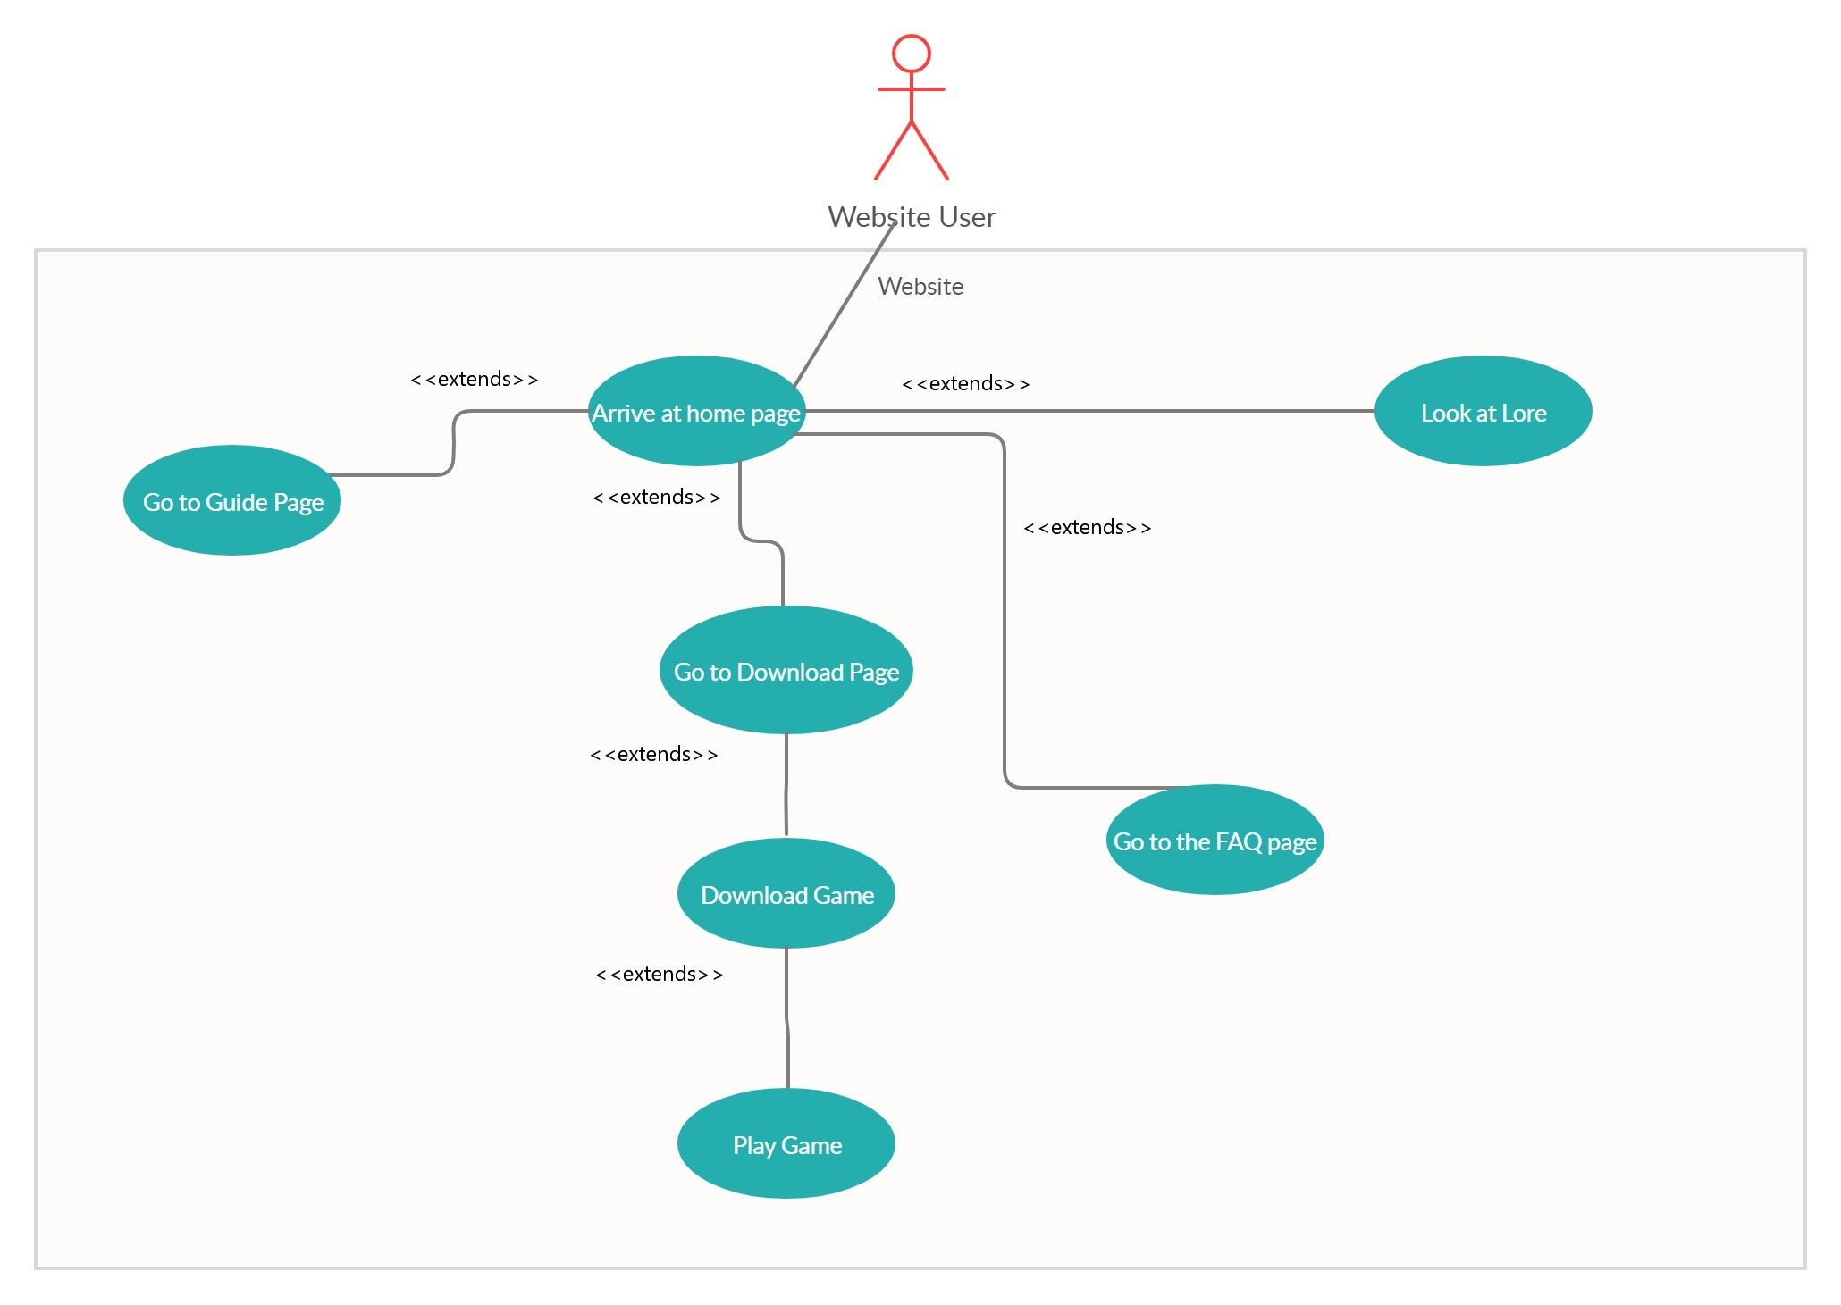

*Textual Description:*

1. Name: Access Website
2. Participating Actors: Website User
3. Entry Condition: User loads correct url and has internet connection
4. Exit Condition: User leaves webpage or closes window
5. Flow of Events:
   1. User arrives at homepage
   2. Can go to Guide Page, Lore Page, FAQ, or Download Page
   3. If they go to Download Page, they can Download the game
   4. Once downloaded, user can play game
6. Special Requirements: None.

Game Use Case Diagram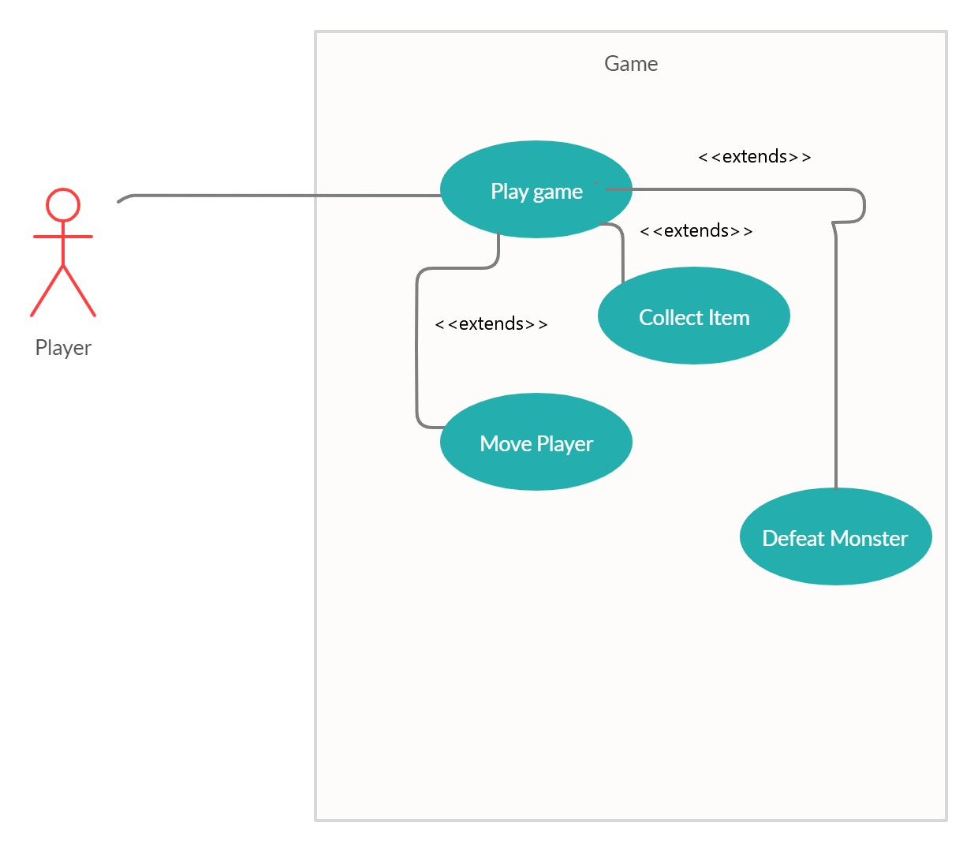

*Textual Description:*

1. Name: Play Game
2. Participating Actors: Player
3. Entry Condition: Player downloads game from website and has appropriate software to run jar files
4. Exit Condition: Player loses or quits game
5. Flow of Events:
   1. Player loads game and clicks “Start Game” on menu
   2. Player moves throughout game by using arrows
   3. Player can collect items and defeat monsters
   4. Player either wins by going up five floors or dies trying to
6. Special Requirements: None.

# Class Diagram and/or Sequence Diagrams

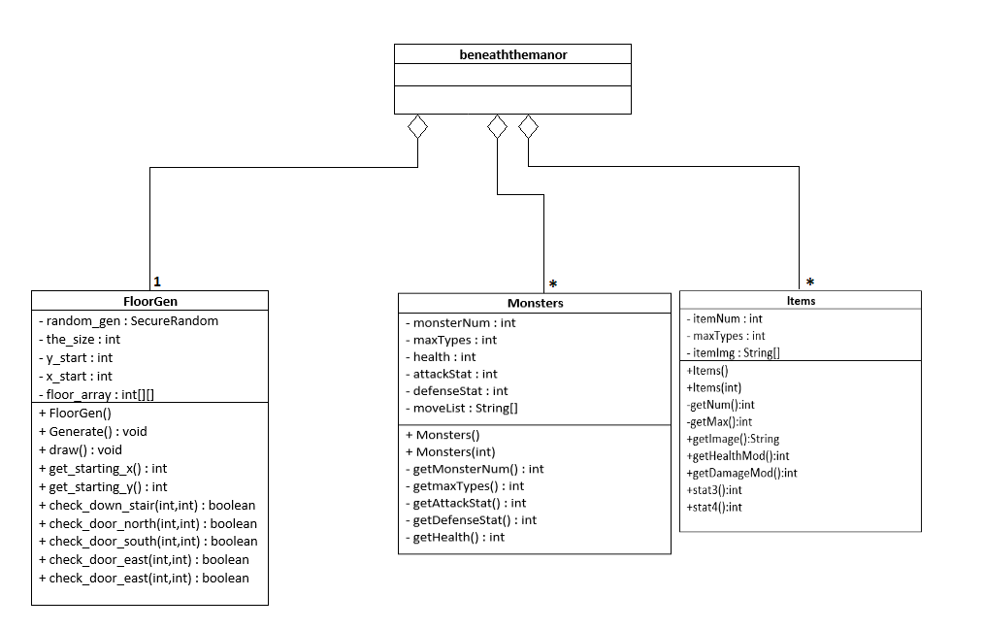

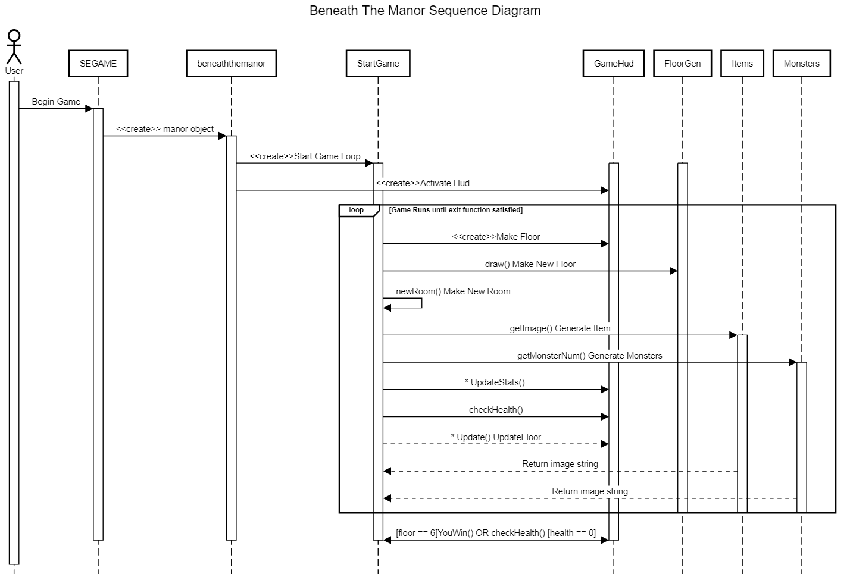

# Operating Environment

The game is intended for personal computers. The game is written in Java, and the minimum runtime environment for our project is Java 8.0. The website runs on all modern desktop browsers and mobile browsers. Website is written using HTML, CSS, and Javascript. Bootstrap CSS libraries were used as well.

# Assumptions and Dependencies

The user knows how to run a jar file.

The user has Java 8 runtime environment installed.

We assume the user has access to the link via internet to the website through Amazon Web Services hosting platform.

We are dependent on the Bootstrap and AOS open source libraries to be properly working once we are finished.